Ipswich and District Rifle Club’s Prize Meet 2016

July 31st sees Ipswich and District Rifle Club hold their annual Open Prize meet. Fullbore shooters from around the south east corner, including some of Australia’s top riflemen will head to Ipswich to compete in the event. The testing conditions of Ipswich’s Ripley range provide an invaluable preparation for the upcoming State Championships held in August.
Competiton will commence at 9.00 am sharp and will continue until mid afternoon. BBQ lunch and canteen will be available on the day. Get along and support your Ipswich riflemen and see what target sports has to offer. You can catch the action at 1494 Ripley Rd, South Ripley on the 31st.
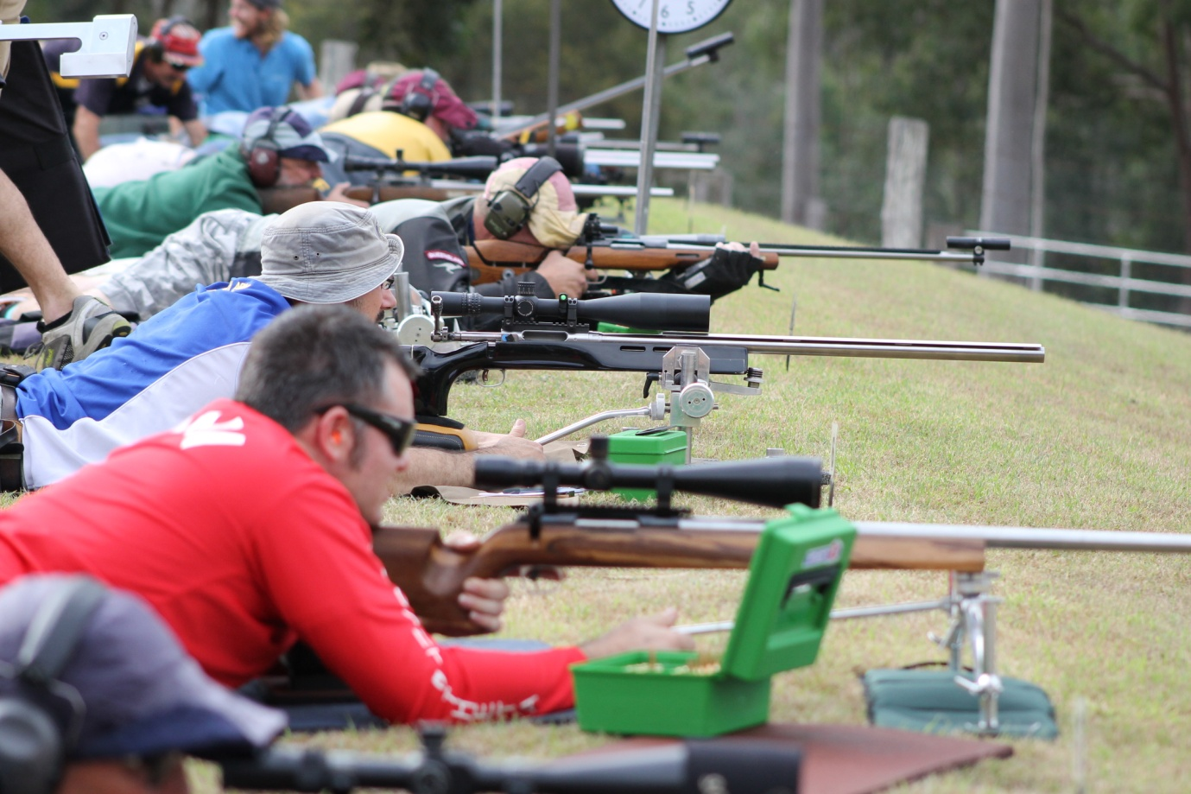
Firing line at IDRC’s 2015 Prize Meet

